To Build or to Buy
a Medical Grade IoT Platform, That’s The Question

Table of content
Executive Summary 3
The Market Landscape 4
The Dilemma 5
Option A: The In-house “From Scratch” Route 6-7
Option B: Adopting a SaaS Connected Care Platform 8-9
BioT Innovation Delivers Value from Day One 10-11
Build vs. Buy 12-13
Conclusion 14-15

Executive Summary
Medtech and Pharma decision-makers are currently facing a dilemma. Internet of Things (IoT) and cloud computing have taken the world by storm. When it comes to medical devices, these two technologies have created an entirely new industry called Connected Care that dramatically expands the benefits that medical devices offer. These benefits have become even more relevant in light of the radical upheaval in medical provision caused by Covid-19. However, many medical device providers are unsure as to the best approach to take when pivoting their operations towards IoMT solution vendors. Should they build their Connected Care product in-house, almost from scratch, or turn to a commercial, off-the-shelf IoMT platform?

This white paper will review the advantages and disadvantages of each of the two approaches. The goal of this paper is to help you decide which approach is the best for your company.

The Market Landscape
Across the world, industries from finance to media, commerce and travel are undergoing digital transformations to empower collaborative, distributed business models and on-demand resources. Yet the medical device industry has been slow to jump on the cloud bandwagon. Until recently, the critical nature of medical service provision, combined with knowledge gaps, performance concern, reliability, regulatory compliance, data privacy, and more, have, kept medical providers hesitant about the cloud, despite the clear benefits it provides.

However, recent societal changes are upending the equation. Patients are clamoring for new measures that reduce their need to physically visit clinics and hospitals, mostly because of overcrowding and fear of contagion.

Furthermore, with software becoming more and more prominent in each and every sphere, the new types of “builders” (i.e., no code/low code development platforms)give the freedom to develop robust solutions that are hassle-free and on a fast development track.

These trends, coupled with the emergence of value-based care that financially incentivizes remote monitoring and reduces hospitalization time, are causing many medical providers to revisit their previous concerns about the cloud.

The Dilemma
The path toa complete medical device solution requires medical device companies to address the connectivity, collaboration and care domains. On the connectivity side they need to make sure to address security, privacy and cloud-related aspects to enable smooth data transfers and device management. On the collaboration side, they are required to provide a platform that enables patient-caregiver workflows. Finally, on the care side, they need to enable the ability to support an advanced analytical layer by running device-specific algorithms alongside generic functions such as adherence and efficacy.

While medical device manufacturers understand the importance and potential of introducing medical devices which support the continuum of care, they face significant challenges when building and launching connected care solutions.

Taking into consideration the challenges listed above, Biopharma and MedTech executives are faced with a dilemma whether they should build their own connected care solutions from scratch, or license a commercial, off-the-shelf scalable IoMT platform that meets each company’s needs. Both approaches have advantages and disadvantages.

We will discuss both options in this white paper.

Option A:
The In-house “From Scratch” Route
The thought of building a IoMT solution that is custom-designed to support your specific needs and strategy is enticing. However, there are many issues to consider before making such an important decision. While there are definitely advantages to building in-house, the disadvantages far outweigh any strategic gain you may potentially achieve.
Building a custom IoMT solution from scratch enables medical device manufacturers to benefit from a solution that meets their specific needs and provides full control over the process and data. However, this customization and control comes with a long list of challenges that must be overcome before any benefit can be realized.

- Time to market. Building your own custom solution from scratch takes a significant amount of time; between 1-3 years. This means that there’s a good chance that by the time your solution is ready, the needs of the market will have progressed beyond the capabilities that you’ve developed. Additionally, there is no guarantee that you be successful. According to Gartner, 75% of IoT projects take longer than planned.
- Prohibitive costs. Building your own IoMT platform is a risky endeavor. Even successfully getting it up and running, there’s a good chance the system still won’t be fully optimized, which can translate into higher initial setup costs and increased long-term, ongoing expenses.
- Privacy and security risks. Complying with HIPAA, GDPR, and other regulatory requirements while managing an ever-increasing number

of cybersecurity threats is time-consuming and demands significant resources and expertise. New regulations are constantly being introduced, and often vary from country to country, while new security threats are discovered on a daily basis. This means that resources must be constantly allocated to ensure a secure, compliant IoMT platform.
- Team building. Building and maintaining an IoMT solution requires expertise from a wide variety of different professionals such as digital health software engineers, security and privacy experts, data analysts, and Cloud and IoT experts. Not to mention remote patient care product experts that will need to be hired to make sure that your new product does not run into adherence issues or reimbursement walls.
- Not the core competency of the company. Your competitive advantage is derived from the specific competencies, IP and value proposition that form the core of your company’s offering - i.e., your proprietary device and data algorithms. Although IoMT platforms drive impressive capabilities and empower an enhanced user experience for patients, building the core infrastructure yourself does not deliver a significant competitive advantage.

For all of the reasons listed above and others, Gartner advises life science companies to partner with technology companies instead of “reinventing the wheel”.
Option B:
Adopting a SaaS Connected Care Solution
Opting for a pre-built commercial Connected Care platform offers medical device manufacturers plenty of advantages over building it themselves. The advantages go way beyond cost/benefit calculations, extending into the long-term strategic benefits and competitive advantages that a robust IoMT platform provider can deliver to ensure a seamless continuum of care.

- Significantly shorten time to market. Partnering with a no-code PaaS (Platform-as-a-service) provider like BioT significantly speeds up the time it takes to connect your medical devices to the cloud and create personalized experience for patients - up to 90% faster.
- Reduced privacy and security risks. Using an off-the-shelf IoMT platform means you don’t have to reinvent the wheel; the platform ensures regulatory compliance and minimizes cybersecurity risks as part of its core offering. Fully managed cybersecurity teams constantly monitor the threat landscape, ensuring that the platform is always protected from new cyber threats and remains compliant with the latest regulations. Moreover, IoMT platform vendors share legal responsibility for security and privacy risks for the medical device companies they cater to.

- Personalized patient experience. Many connected medical device solutions fail not because the device is ineffective, but because patients did not adhere to the prescribed protocol or felt disengaged while using the device. Patient adherence is just one problem related to the domain of remote human behavior. Conversely, BioT makes remote/home care accessible by boosting personalized engagement and improving health outcomes through collaboration between patients, caregivers and medical devices.
Unlike medical device companies that need to allocate their resources across multiple medical domains, SaaS IoMT platforms invest significant resources in remote human behavior.
¹ Based on BioT implementations vs. industry standards

BioT facilitates better patient care by using data-driven actionable insights to improve clinical decision-making and care experiences.

- New business models. Partnering with a third-party IoMT platform empowers a range of innovative, new business models. These include smart, connected, pay-per-use services, inventory info on disposables, adherence, consent and other healthcare-related workflows and features which are integrated in the platform and support additional business models. Specifically, the issue of reimbursement, a major obstacle to the widespread adoption of RPM (Remote Patient Monitoring). Providers can now leverage CPT codes that enable reimbursement for an operation and provision for medical equipment used to remotely deliver patient care, and thus generate additional revenue streams.

- Lower OPEX costs. Operating expenses associated with running a large-scale IoMT platform can cost millions of dollars a year. SaaS IoMT platforms are usually built from the ground-up to support high-scale performance at minimum cost. Additional OPEX savings are derived from eliminating the need to maintain dedicated internal teams to support compliance with ongoing cybersecurity and privacy regulations.

Connected Care Platforms Cut Long-Term Costs by up to 500%:
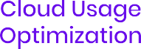

BioT’s Medical-Grade No-Code Platform Delivers Value from Day One

BioT is the first of its kind no-code platform that securely transforms medical devices into connected care solutions in just one day. Our Triple-C Connect-Collaborate-Care solution enables our customers to securely connect devices to a medical-grade cloud, boost personalized engagement and improve health outcomes through collaboration between patients and caregivers, and turn data into actionable insights to improve clinical decision-making and care experiences.

The BioT Connected Care platform was built with the needs of medical device providers in mind. BioT seamlessly and securely connects medical devices to the cloud using ready-made modular templates, simplifies data management and facilitates fully secure and remote clinical care. BioT offers preconfigured solutions to critical issues such as HIPAA, cybersecurity, and data anonymization. All BioT solutions are in strict accordance with rigid FDA and ISO standards for cloud software.

BioT enhances security for Vectorious through the built-in HIPAA and GDPR compliance capabilities. “These capabilities help us reduce our cybersecurity risk and avoid penalties or even device recall from failure to comply”
Keren Raiten, formerly of Vectorious Tech, currently, VP at Orca AI
Head of Marketing for Vectorious Medical Technologies

BioT is more than just a platform. By including a built-in development framework, BioT enables device/web/mobile developers to build applications that interact with the backend via SDKs. BioT offers full implementation with no need for development by providing a multitude of templates and plug-in code options, to easily run your own algorithm and unique workflows in the cloud.

BioT’s no-code PaaS model ensures that control over the IoMT end solution -- and the valuable data that it generates -- remains in the hands of the device company. This is achievable because BioT is installed on the customer’s cloud account.

Cutting-edge technology is at the core of the BioT Connected Care PaaS solution. Its advanced module architecture enables long-term cost savings and scalability to support millions of connected devices streaming data simultaneously.

With BioT, medical device manufacturers can transform themselves into connected care solutions capable of successfully managing even the most complex remote care operations. This is possible by leveraging unique, industry-proven connected care features and industry-leading cybersecurity, regulation and compliance measures.

Build vs. Buy
Time-to-market is Years Longer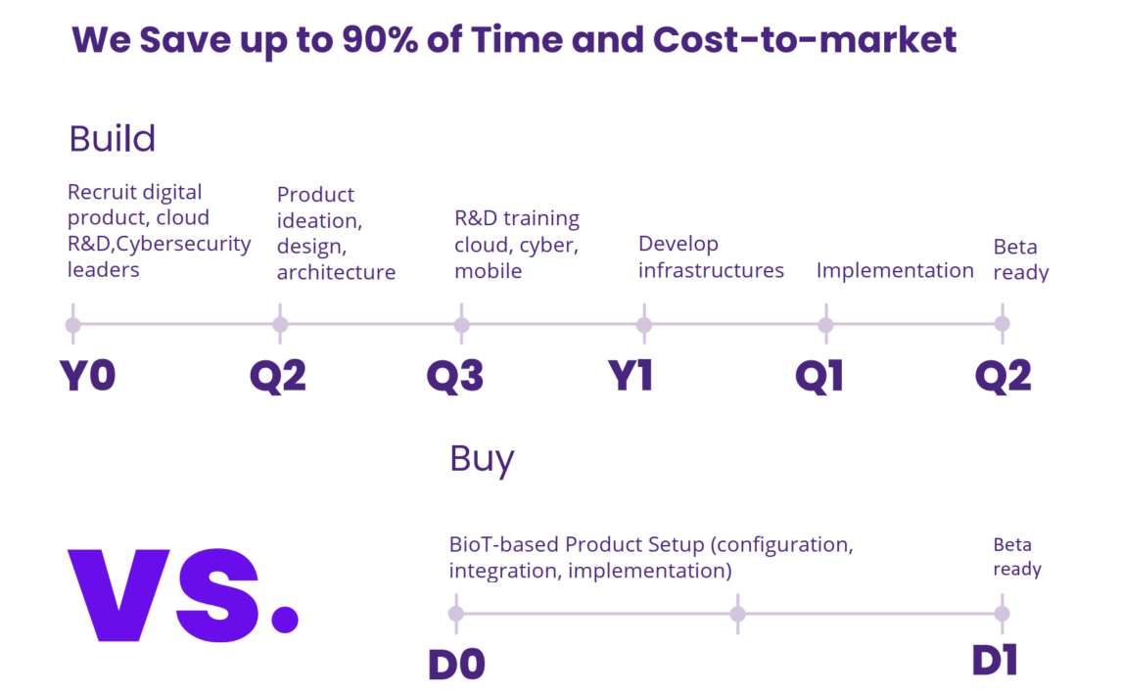

*Process of development of an IoMT solution, based on BioT implementations vs. industry standards

BioT securely transforms medical devices into Connected Care solutions within ONE DAY..

- Reduce the time to build from one year to one single day!

- Avoid the risks of SaaS regulation compliance, security and scalability

- Optimize treatment efficacy and improve health outcomes

- Collect accurate data for PMCF and clinical trials

- Create brand loyalty and increase patient satisfaction with personalized experience

- Generate more revenue

Conclusion
Building an IoMT platform requires consideration of issues that have long-term impact on your business.
While one may think that building your own platform ensures control and freedom, there are numerous challenges involved that put a damper on these advantages. Finding the right experts, slow time-to-market, mastering and mitigating privacy, security and regulatory risks, and securing the substantial resources required to cover not only the initial investment, but also the ongoing maintenance of the IoMT solution are all factors that need to be taken into account. Ultimately, you need a solution that will enable you to quickly leverage the benefits of the cloud while reducing cyber security and privacy compliance risks.

The use of a connected care platform, like BioT’s, allows you to circumvent the risks and costs of building a custom Connected Care solution while retaining maximum control over your data and freedom to build your bespoke solution. You can benefit from a robust product that delivers advanced, out-of-the box data-driven capabilities

that have proven themselves in numerous

deployments over years of operation. Choosing a commercial off-the-shelf solution like BioT’s offers you operational peace of mind while significantly reducing time to market.

BioT’s game changing no-code Platform-as-a-Service delivers a compelling solution for the medical device space. Highly customizable to support any device, BioT delivers out-of-the-box capabilities that empower new business models and is capable of adapting to your changing needs while ensuring full compliance and data security.

For more info:

www.biot-med.com @biot-

