DermShield White Paper

Abstract
DermShield is a proprietary complex technology. It is a novel protective complex (NPC). This proprietary protective complex is a breakthrough in skincare, providing a temporary selective inhibitor complex. DermShield technology, an integral component of Noon’s Paraceutical skincare line which enables unprecedented high concentration levels of active ingredients without the usual, painful side effects associated with such treatment protocols.

Introduction
The concept of the peel is to resurface and rejuvenate the skin. Chemical peels are a popular, effective, non-invasive and relatively safe method to improve skin appearance and treat various skin problems such as acne, pigmentation, scars, wrinkles, etc. By inducing a controlled injury to the skin’s surface, a chemical peel works by removing the upper layer or layers of the epidermis. The skin’s natural healing process then works to generate a new, smoother surface - thus reducing acne scarring, fine lines and other contour issues. The ultimate goal of a skin peel is an improvement in texture along with a reduction in discoloration.

The aim of the application of a chemical peel is to treat the skin via a chemical agent and create a change of the structural elements of the skin. These are commonly used in clinical settings and are found in many cosmetics.…

Chemical peels are categorized into 4 groups: enzymatic peels, pH-peels, retinoid peels and keratolytic peels. These are further classified according to their depth of penetration and desquamation of the skin.

The challenge with most therapeutic skin care products is to maximize the therapeutic benefits. Such as with chemical peels and creams, which would require high acid concentration and a low pH. With high concentration treatments this may lead to undesirable side effects though, such as itching, stinging, erythema, edema and discomfort.

The efficacy of skincare products is directly related to their active ingredients. In order for skincare products to have high efficacy, the active ingredients must contain a high concentration and a low pH. However, most established skincare companies reduce the concentration of active ingredients to reduce painful side effects. This balance between product efficacy and side effects means that many products are either less effective or require frequent applications to achieve the same results.

The DermShield Difference

DermShield technology is a breakthrough approach to skincare, impacting the ability of professional skincare providers to deliver highly effective, safe and irritation free skin treatments.

DermShield technology has paved the way for the development of a paraceutical skincare product-line that contains unprecedented high levels of active ingredients, enabling highly effective, safe and irritation-free treatments; no burning, redness, edema, erythema, itching, stinging or any unpleasant sensations.

When skin peeling products containing the active ingredients are applied to the skin, nerve fibers called Type C Nociceptors are activated. This results in neurogenic inflammation, blood vessels dilate causing redness, erythema and edema. Mast cells are also activated releasing histamines. The nerve pulse continues to the brain causing painful sensations such as stinging, burning and itching.

As an NPC, DermShield, creates a temporary selective inhibitor complex that temporarily and directly reduces the transmission of the skin’s chemical irritation reaction, activation of Type C Nociceptors is reduced, neurogenic inflammation and the accompanying side effects are avoided. The nerve impulse to the brain is decreased and so the painful side effects are significantly reduced. The created synergistic effect created by DermShield leads to an overall decreased development, incidence and severity of skin irritation, erythema and pain.
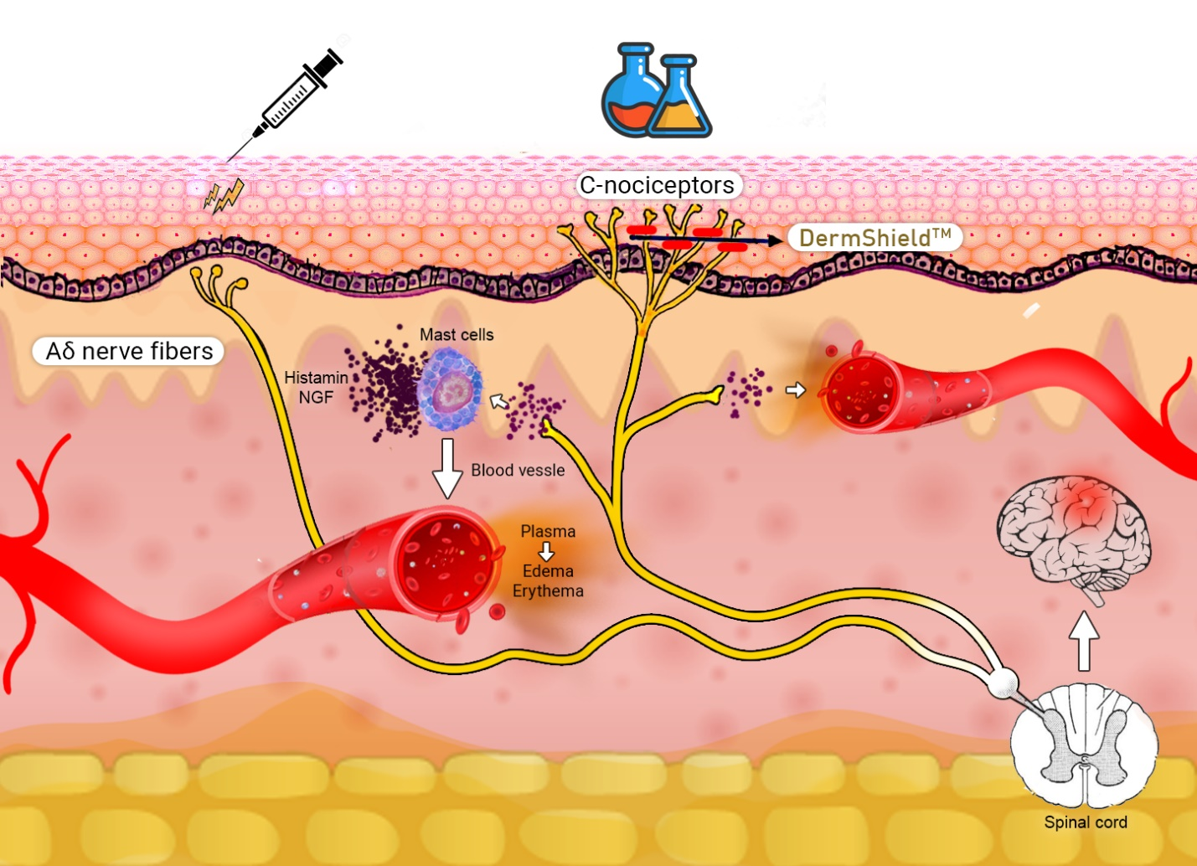

With DermShield enhanced products, patients of all ages, genders and all Fitzpatrick skin types with all manner of skin ailments can be treated year-round. DermShield products have been proven effective for the treatment of conditions such as hyperpigmentation, loss of elasticity, sun damage, acne, seborrhea and aging which can be treated, leading to healthy and beautiful skin.

Clinically proven

Most pH peels include AHA (Alpha-Hydroxy Acids), PA (Pyruvic Acid) and GA (Glycolic Acid). Glycolic acid is one of the more common active ingredients of the superficial peels. All AHA peels are classified as superficial peels, regardless of concentration and pH value, and in the case of AHA and Pyruvic Acid peels, the depth of penetration and the depth of damage/desquamation vary.

The intensity of desquamation (the strength of these peels) depends on the following factors: pH, acid concentration, acid strength, exposure time and mandatory subsequent neutralization and skin condition of the patient.

While glycolic acid is a widely used component of chemical peels in clinical practice, the pH ranges are generally from 0.08-2.75 and must be neutralized after application to avoid burns.¹ However, DermShield technology allows for a stronger compound. The safety of the NPC (DermShield) was further demonstrated in a prospective, double-blind, split-face controlled study conducted from January 2019 through March 2019. In this trial, NPC (DermShield) combined with Glycolic acid 50%. All of the participants in the study were healthy females between the ages of 40 and 54 years old. Most notably, the participants were Fitzpatrick skin types I, II and III.

At the end of the trial, the researchers concluded that the addition of the NPC (DermShield) to GA 50% peel is ‘’a highly effective, safe modality in the reduction of erythema, pain and itching sensation after peel application, and provides an advantage in the post-treatment healing period’’.²

All products containing DermShield are based on the latest technologies by researchers with deep knowledge of the functioning of the skin and the interaction between skin and chemical substances.

- In Jae, J., Dong Ju, H., Dong Hyun, K., Yoon, M.S. and Lee, H.J., 2018. Comparative study of buffered 50% glycolic acid (pH 3.0) + 0.5% salicylic acid solution vs Jessner's solution in patients with acne vulgaris. Journal of cosmetic dermatology, 17(5), pp.797-801.
- Kalluri H, Banga AK. Transdermal delivery of proteins. AAPS PharmSciTech. 2011;12(1):431-441. doi:10.1208/s12249-011-9601-6

